The Flower in the Snow
Tune: Julian of Norwich Set: 6 dancers, two 28 ¼“ (medium) sticks per dancer, single steps Source: Red Herring / Jeff Bigler (2015) Chorus: 1st triangles clash self, right (basket), self, left (basket), spin & pass through beyond corner's place, loop & return to corner's place. 2nd triangles clash self, left (with right stick of dancer to your right), self while looping behind that dancer, left (with left stick of same dancer), twirl twice to advance one more place around the set. You are now corner-crossed (and triangles are switched). Repeat chorus to get home. Figures: dance on (triangles), grand right & left, solar system, vines

Detailed Description
This dance was written in 2015 as a tribute to Vonnie Carts-Powell. The tune, Julian of Norwich, was one of her favorite songs.

Chorus
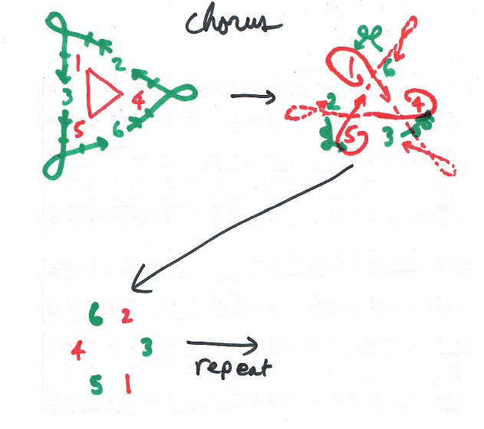
First triangle (dancers 1, 4, 5):
bar 1: clash self (on downbeat)bar 2: clash right stick with each other (on downbeat) and hold left stick for clash from a dancer in the 2nd trianglebar 3: clash self (on downbeat)bar 4: class left stick with each other (on downbeat) and hold right stick to receive clash (from behind) from a dancer in the 2nd triangle.bars 5-8: turn (single) 360° over right shoulder, dance through next open triangle position, loop around (over left shoulder) and back in, ending up corner-crossed from your original position.Second triangle (dancers 2, 3, 6):
bar 1: clash self (on downbeat) and turn approximately 90° over right shoulderbar 2: clash left stick with the first triangle dancer who started on your right as you pass the dancer heading out from the setbar 3: clash self as you loop around over your right shoulder behind the dancer you just clashed withbar 4: clash left stick again with the same dancer (approaching from behind) to end up on the opposite side of that dancerbars 5-8: twirl twice over right shoulder, advancing one additional place around the circle, ending up corner-crossed from your original position.After 8 bars, all dancers are corner crossed. Dancers who started in positions 1, 4, and 5 are now in positions 2, 3, and 6 (i.e., are now second triangles), and dancers who started in positions 2, 3, and 6 are now in positions 1, 4, and 5 (i.e., are now first triangles). Repeat chorus, with all dancers ending up back in their original places.

Figures

Dance On
Beats 1-8: First triangle dances on. When they reach the center, dance 360° around and back out to place. Beats 9-16: Second triangle dances on. When they reach the center, dance 360° around and back out to place. Meanwhile, first triangle continue out from your place, loop around and back to place.

Grand Right & Left
The figure starts with #1, #4 and #5 facing counter-clockwise, and #2, #3 and #6 facing clockwise. This means the figure starts with #1 facing #3, #2 facing #4, and #5 facing #6. The dancers dance around the circle, clashing on the odd-numbered beats. Beats 1-2: Dancers pass right shoulders with a clash (beat 1) and continue to the next person. Beats 3-4: Dancers clash (beat 3) and pass the next dancer by the left shoulder and continue. Beats 5-12: Continue passing alternate shoulders, with clashes on the odd-numbered beats.
Beats 13-16: Pass one additional person by the right and then dance around that person back to place.

Solar System
Beat 1: Dancers clash as they pass by the right shoulder. The clash defines which direction they travel around the circle and how far out. Beat 2: Dancers continue around in their orbit. Beat 3: Dancers clash as they pass, ¼ of the way around the circle (90°) from their starting point. Beat 4: Dancers continue. Beat 5: Dancers clash as they pass, ½ way around the circle (180°) from their starting point. Beat 6: Dancers continue. Beat 7: Dancers clash as they pass, ¾ of the way around the circle (270°) from their starting point. Beat 8: Dancers continue.
Repeat on beats 9-16.

Vines
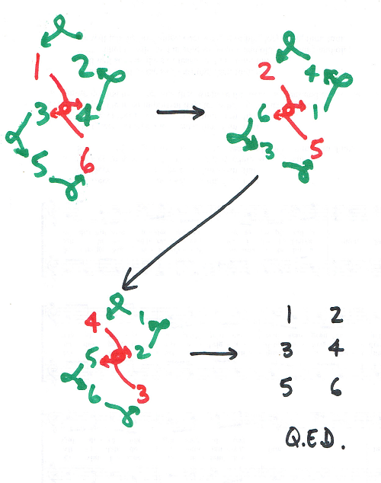
Beats 1-4: First corners dance around each other 270° (by the right shoulder) and come out in the middle on the opposite side. Other dancers twirl (around right shoulder) one place anti-clockwise. Beats 5-8: Repeat with new first corners (who were previously 2nd corners) Beats 9-12: Repeat with new first corners (who were previously middles) At the end of beat 12, you should be in your original place. Beats 13-16: Gypsy with your partner (across the set).

Tune

