The Impossible Dance
Tune: William Taylor's Tabletop Hornpipe, by William Taylor Set: 6 dancers, 32“ (long) sticks, single steps Source: Boggart's Breakfast Chorus: spin & toss. Repeat. Figures: hot cross buns, collapse the set, swiss roll, spotted dick
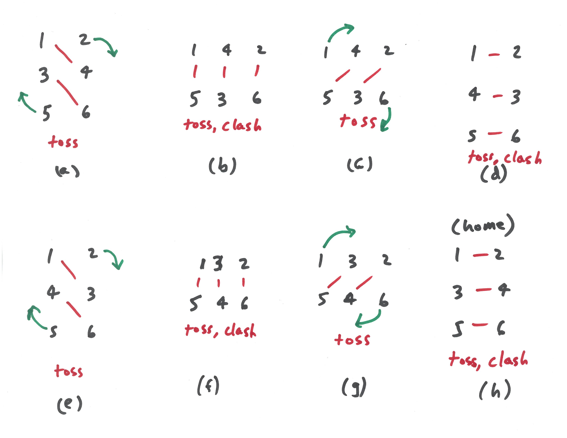Impossible Dance Chorus

Tune

